TRADEVO
Database Design Document (DDD)

Document Information
Field | Value
Document Name | Tradevo Database Design Document
Version | 1.1
Status | Draft
Prepared By | Sachin Chaubey
Classification | Internal Use Only
Date | 29 June 2026

Revision History
Version | Date | Description
1.0 | 29 June 2026 | Initial Draft
1.1 | 29 June 2026 | Refined business entities, replaced AI Memory with AI Observation, added Learning Session, converted Investment DNA to historical records.

Table of Contents
- Introduction
- Database Design Goals
- Database Design Principles
- Business Entities
- Entity Relationships (To Be Developed)
- Conceptual Data Model (To Be Developed)
- Logical Database Model (To Be Developed)
- Physical Database Design (To Be Developed)
- Constraints & Integrity Rules (To Be Developed)
- Future Evolution (To Be Developed)

1. Introduction
1.1 Purpose
This document defines the logical data model for the Tradevo platform. It identifies the business entities, their responsibilities, and the relationships required to support portfolio management, AI intelligence, behavioral learning, and investment research.

1.2 Scope
Included
- Business entities
- Entity relationships
- Conceptual data model
- Logical schema
- Data integrity principles
Excluded
- APIs
- Application logic
- AI implementation
- User interface
- Deployment

2. Database Design Goals
Goal ID | Goal
DB-G01 | Maintain data consistency.
DB-G02 | Eliminate unnecessary data duplication.
DB-G03 | Preserve complete historical records.
DB-G04 | Support AI learning through structured data.
DB-G05 | Enable modular system development.
DB-G06 | Support future scalability and extensibility.

3. Database Design Principles
DB-P01 — Single Source of Truth
Each business concept shall have one authoritative representation.

DB-P02 — Referential Integrity
Relationships between entities shall be maintained through appropriate constraints.

DB-P03 — Historical Preservation
Historical investment and behavioral records shall be retained to support analytics and AI learning.

DB-P04 — Separation of Responsibilities
Operational data, analytical data, AI-generated data, and reference data shall remain logically separated.

DB-P05 — Extensibility
The database shall accommodate future product features without major structural redesign.

4. Business Entities

ENT-001 — User
Purpose
Represents a registered Tradevo user.
Owns
- Portfolio
- Watchlist
- Learning Sessions
- Investment DNA History
- AI Observations
- Notifications

ENT-002 — Portfolio
Purpose
Represents a user's investment portfolio.
Contains
- Holdings
- Cash Balance
- Portfolio Metrics
- Portfolio Performance

ENT-003 — Transaction
Purpose
Represents every buy, sell, or simulated investment performed by the user.
Used By
- Portfolio
- Learning Engine
- Decision Timeline

ENT-004 — Company
Purpose
Represents a publicly traded company available for investment and research.
Contains
- Company Profile
- Industry
- Sector
- Market Information

ENT-005 — Watchlist
Purpose
Stores companies bookmarked by the user for future monitoring.

ENT-006 — Investment DNA History
Purpose
Stores historical snapshots of the user's behavioral profile instead of only the latest state.
Examples
- Risk Appetite
- Diversification Score
- Research Discipline
- Emotional Stability
- Holding Patience
Purpose of History
Allows visualization of behavioral evolution over time.

ENT-007 — Decision Timeline
Purpose
Maintains a chronological record of every investment decision together with its surrounding context.
Stores
- User Decision
- Decision Time
- AI Feedback
- Market Context
- Investment Outcome

ENT-008 — Deep Research Report
Purpose
Stores AI-generated research reports requested by users.
Includes
- Executive Summary
- Company Analysis
- Financial Analysis
- Risk Assessment
- Supporting Evidence
- Generated Timestamp

ENT-009 — AI Observation
Purpose
Stores long-term AI-generated observations about user behavior.
Unlike Investment DNA, observations represent individual findings rather than aggregate scores.
Example Observations
- Frequently exits profitable positions early.
- Rarely researches companies before investing.
- Frequently concentrates investments in one sector.
- Improves performance after completing simulations.
Used By
- Memory Engine
- Learning Engine
- Decision Engine

ENT-010 — Learning Session
Purpose
Represents one complete learning or simulation session.
Stores
- Session Duration
- Companies Studied
- Simulated Trades
- Mistakes Identified
- Lessons Learned
- Improvement Summary
Purpose
Allows Tradevo to measure learning progress instead of only counting transactions.

ENT-011 — Notification
Purpose
Stores alerts, reminders, warnings, and informational messages generated for users.

ENT-012 — Market Snapshot
Purpose
Represents the state of the market at a specific point in time.
Examples
- Major Indices
- Sector Performance
- Volatility Indicators
- Economic Conditions

ENT-013 — News Article
Purpose
Represents financial and company-related news consumed by the Research Engine.
Contains
- Headline
- Source
- Publication Time
- Company References
- Sentiment Metadata (optional)

Entity Classification
Category | Entities
User Data | User, Portfolio, Watchlist
Investment Data | Transaction, Company
AI Data | Investment DNA History, AI Observation, Decision Timeline
Learning Data | Learning Session
Research Data | Deep Research Report, Market Snapshot, News Article
System Data | Notification

Design Notes
- The Memory Engine is not a database entity. It is an AI component that retrieves historical information from existing entities.
- Investment DNA is stored as historical snapshots to preserve behavioral evolution.
- AI Observations represent individual behavioral insights generated by AI over time.
- Learning Sessions measure educational progress independently of transaction history, enabling richer coaching and analytics.

Chapter 5 – Entity Relationships

5. Entity Relationships
This chapter defines the logical relationships between business entities. These relationships describe how information is associated within the Tradevo platform and form the basis of the Entity Relationship (ER) Model.

5.1 Relationship Summary
Relationship ID | Relationship | Cardinality
REL-001 | User → Portfolio | 1 : 1
REL-002 | User → Watchlist | 1 : N
REL-003 | User → Transaction | 1 : N
REL-004 | User → Learning Session | 1 : N
REL-005 | User → Investment DNA History | 1 : N
REL-006 | User → AI Observation | 1 : N
REL-007 | User → Notification | 1 : N
REL-008 | User → Deep Research Report | 1 : N
REL-009 | Portfolio → Transaction | 1 : N
REL-010 | Watchlist → Company | N : 1
REL-011 | Transaction → Company | N : 1
REL-012 | Learning Session → Transaction | 1 : N
REL-013 | Decision Timeline → Transaction | 1 : 1
REL-014 | Decision Timeline → AI Observation | 1 : N
REL-015 | Deep Research Report → Company | N : 1
REL-016 | News Article → Company | N : 1 (Initial Design)
REL-017 | Market Snapshot → Company | 1 : N
REL-018 | AI Observation → Investment DNA History | N : 1 (Optional)

5.2 Relationship Details

REL-001
User → Portfolio
Type
One-to-One (1:1)
Description
Each registered user owns exactly one portfolio.
Each portfolio belongs to one user.

REL-002
User → Watchlist
Type
One-to-Many (1:N)
Description
A user may maintain multiple watchlist entries.
Each watchlist entry references one company.

REL-003
User → Transaction
Type
One-to-Many (1:N)
Every investment performed by a user creates a transaction.
Transactions remain permanently associated with their owner.

REL-004
User → Learning Session
Type
One-to-Many (1:N)
Each completed learning session belongs to one user.
A user may complete any number of sessions.

REL-005
User → Investment DNA History
Type
One-to-Many (1:N)
Every time Investment DNA is recalculated, a new historical snapshot is stored.
Older snapshots are preserved.

REL-006
User → AI Observation
Type
One-to-Many (1:N)
AI-generated behavioral observations accumulate over time.
Multiple observations may exist for a single user.

REL-007
User → Notification
Type
One-to-Many (1:N)
Each notification belongs to one user.
A user may receive multiple notifications over time.

REL-008
User → Deep Research Report
Type
One-to-Many (1:N)
Users may generate multiple Deep Research reports.
Each report is associated with the user who requested it.

REL-009
Portfolio → Transaction
Type
One-to-Many (1:N)
Every transaction affects exactly one portfolio.
A portfolio consists of many transactions accumulated over time.

REL-010
Watchlist → Company
Type
Many-to-One (N:1)
Each watchlist entry references one company.
The same company may appear in the watchlists of many users.

REL-011
Transaction → Company
Type
Many-to-One (N:1)
Each transaction involves one company.
A company may participate in many transactions across different users.

REL-012
Learning Session → Transaction
Type
One-to-Many (1:N)
A learning session may contain multiple simulated transactions.
Each simulated transaction belongs to one learning session.

REL-013
Transaction → Decision Timeline
Type
One-to-Zero-or-One (1:0..1)
A transaction may generate one corresponding decision timeline entry.
Transactions completed without AI involvement may not create a decision record.

REL-014
Decision Timeline → AI Observation
Type
One-to-Many (1:N)
A single investment decision may produce multiple AI observations.
Example:
- Poor diversification
- Emotional trading detected
- Insufficient research

REL-015
Deep Research Report → Company
Type
Many-to-One (N:1)
Each report analyzes one company.
A company may have multiple research reports generated over time.

REL-016
News Article → Company
Type
Many-to-One (N:1)
Each news article is associated with one primary company.
A company may have multiple related news articles.
Future versions may support articles referencing multiple companies.

REL-017
Market Snapshot
Type
Independent Reference Entity
Market Snapshot stores the state of the market at a specific point in time.
It is referenced by analytical components such as:
- Decision Timeline
- Deep Research Report
- AI Analysis
It does not maintain direct ownership relationships with business entities.

REL-018
AI Observation → Investment DNA History
Type
Many-to-One (N:1) (Optional)
Multiple AI observations may contribute to a single Investment DNA snapshot.
This relationship enables explainability by linking behavioral observations to the generated Investment DNA.

5.3 Relationship Integrity Rules
Rule ID | Rule
IR-001 | Every Portfolio shall belong to exactly one User.
IR-002 | Every Transaction shall belong to one Portfolio and one User.
IR-003 | Every Learning Session shall belong to one User.
IR-004 | Every Deep Research Report shall reference one Company.
IR-005 | AI Observations shall always be associated with a User.
IR-006 | Investment DNA snapshots shall never overwrite previous snapshots.
IR-007 | Decision Timeline entries shall reference at most one Transaction.
IR-008 | Market Snapshot records are read-only after creation.

5.4 Relationship Design Summary
The Tradevo data model follows a user-centric design.
The User entity acts as the root of the majority of business relationships, while Company serves as the central reference entity for investment-related information.
AI-specific entities (Investment DNA History, AI Observation, Decision Timeline) are intentionally separated from operational entities (Portfolio, Transaction) to maintain clear boundaries between business operations and AI intelligence.
Reference entities (Market Snapshot and News Article) remain independent to support historical analysis and future expansion.

Chapter 6 – Conceptual Data Model (ER Model)

6. Conceptual Data Model
6.1 Purpose
The Conceptual Data Model defines the major business entities and their relationships without considering database implementation details.
This model serves as the foundation for the logical database schema.

6.2 Conceptual Entity Relationship Diagram
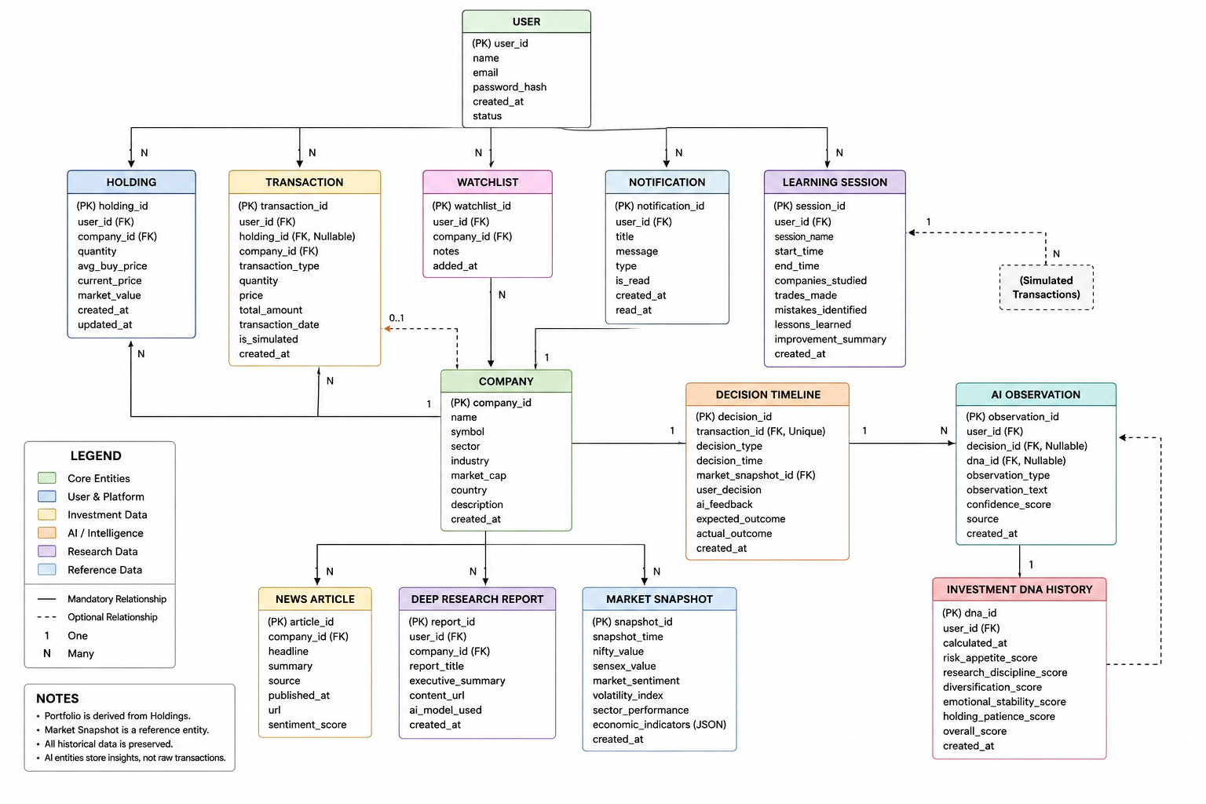

6.3 Relationship Summary
Parent Entity | Child Entity | Cardinality
User | Holding | 1 : N
User | Transaction | 1 : N
User | Watchlist | 1 : N
User | Notification | 1 : N
User | Learning Session | 1 : N
Company | Holding | 1 : N
Company | Transaction | 1 : N
Company | Watchlist | 1 : N
Company | Deep Research Report | 1 : N
Company | News Article | 1 : N
Transaction | Decision Timeline | 1 : 0..1
Decision Timeline | AI Observation | 1 : N
Investment DNA History | AI Observation | 1 : N (Supporting Relationship)

6.4 Entity Categories
Core Entities
- User
- Company
- Holding
- Transaction
These represent the operational data required for the platform.

AI Entities
- Investment DNA History
- AI Observation
- Decision Timeline
These support behavioral learning and personalized intelligence.

Research Entities
- Deep Research Report
- News Article
- Market Snapshot
These provide market context and analytical information.

Platform Entities
- Watchlist
- Notification
- Learning Session
These support the user experience and learning journey.

6.5 Design Decisions
DD-001
Portfolio is treated as a derived business view rather than a persistent entity.

DD-002
Historical data is preserved instead of overwritten to support analytics and AI learning.

DD-003
Operational entities and AI entities are logically separated to reduce coupling.

DD-004
Market Snapshot is modeled as an independent reference entity because it represents market state rather than ownership.

DD-005
AI Observation stores explainable behavioral findings rather than duplicating transactional data.

6.6 Conceptual Model Summary
The Conceptual Data Model represents the business information required by Tradevo while remaining independent of database technology.
It establishes:
- Major business entities
- Ownership relationships
- Reference relationships
- AI data organization
- Research data organization
This model will be transformed into a logical relational model in the next chapter.

TRADEVO
Database Design Document (DDD)
Chapter 7 – Logical Database Model

7. Logical Database Model
This chapter transforms the conceptual entities into logical database structures.
7.1 Core Entities
Entity | Primary Key | Major Relationships
User | user_id | Holdings, Transactions, Watchlist, Learning Sessions, Notifications
Company | company_id | Holdings, Transactions, Research Reports, News
Holding | holding_id | User, Company
Transaction | transaction_id | User, Company, Decision Timeline
Watchlist | watchlist_id | User, Company

7.2 AI Entities
Entity | Primary Key | Relationships
Investment DNA History | dna_id | User, AI Observation
AI Observation | observation_id | User, Decision Timeline
Decision Timeline | decision_id | Transaction

7.3 Learning & Research
Entity | Primary Key | Relationships
Learning Session | session_id | User
Deep Research Report | report_id | User, Company
News Article | article_id | Company
Market Snapshot | snapshot_id | Independent Reference

7.4 Key Design Decisions
- UUIDs are recommended as primary keys.
- Historical entities shall use append-only storage.
- Portfolio values shall be calculated from Holdings.
- AI entities remain logically separated from operational entities.

8. Physical Database Design
Recommended Database
PostgreSQL

Naming Convention
- Tables: snake_case
- Primary Keys: <table>_id
- Foreign Keys: <referenced_table>_id
- Timestamps: created_at, updated_at

Standard Columns
Every transactional table should include:
- Primary Key
- created_at
- updated_at
Where applicable:
- status
- deleted_at (soft delete)

Indexing Strategy
Indexes should be created for:
- Email
- Company Symbol
- User ID
- Company ID
- Transaction Date
- Report Date

Integrity Rules
- Foreign keys shall enforce referential integrity.
- Cascade deletion shall be avoided for historical records.
- Unique constraints shall prevent duplicate watchlist entries.
- Holdings shall never store negative quantities.
- Historical AI data shall never be overwritten.

9. Database Constraints & Integrity
Entity Integrity
- Every table shall have a primary key.
- Primary keys shall be immutable.

Referential Integrity
- Every foreign key shall reference an existing record.
- Orphan records shall not exist.

Business Integrity
- Users cannot own duplicate holdings for the same company.
- Users cannot create duplicate watchlist entries.
- Decision Timeline entries cannot exist without a valid transaction.
- AI Observations cannot exist without an associated user.

Historical Integrity
The following records shall be immutable after creation:
- Transactions
- Decision Timeline
- AI Observations
- Investment DNA History
- Deep Research Reports

10. Future Evolution
The database is designed to support future expansion, including:
- Multi-broker integration
- Multiple portfolios per user
- Multi-asset investments (stocks, ETFs, crypto, commodities)
- Real-money trading
- International exchanges
- Portfolio sharing
- AI model version history
- Advanced analytics

Database Design Summary
The Tradevo database follows a normalized, modular, and history-preserving design.
The model separates:
- Operational Data
- AI Data
- Research Data
- Learning Data
- Reference Data
This separation improves scalability, maintainability, and supports future feature expansion without major schema redesign.

Document Approval
Field | Value
Prepared By | Sachin Chaubey
Version | 1.1
Status | Draft

End of Database Design Document

